1. **create table**

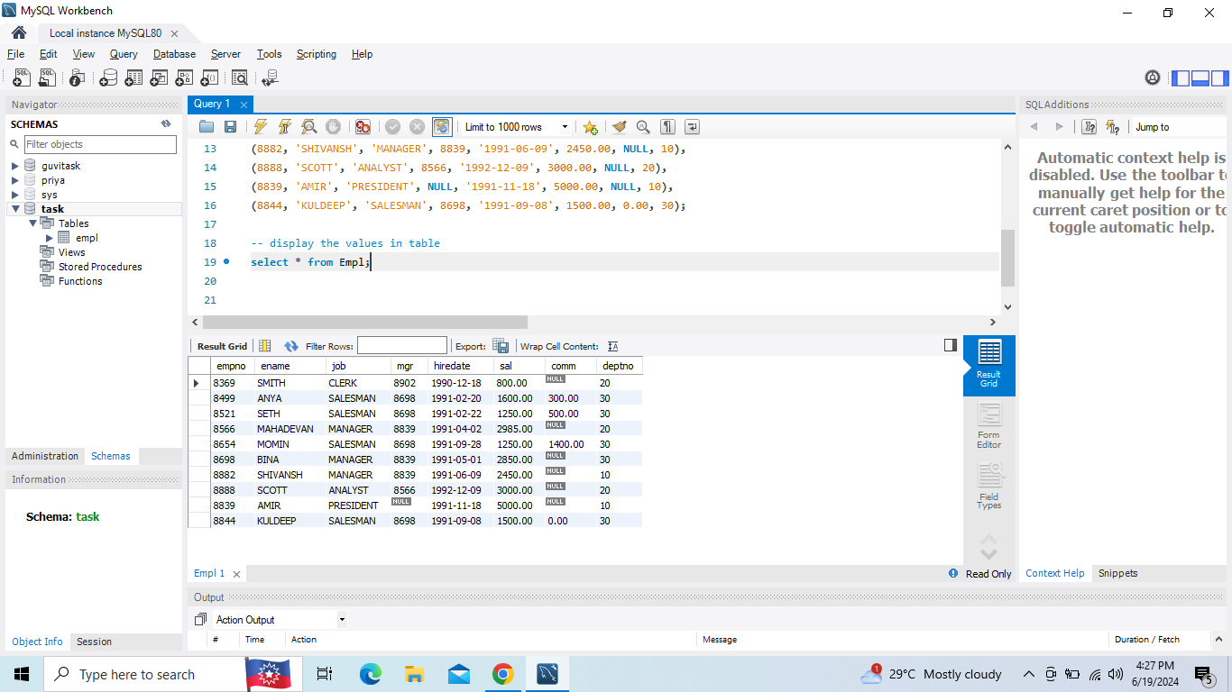

**1)A . Display whose salary is greater than or equal to 2200**

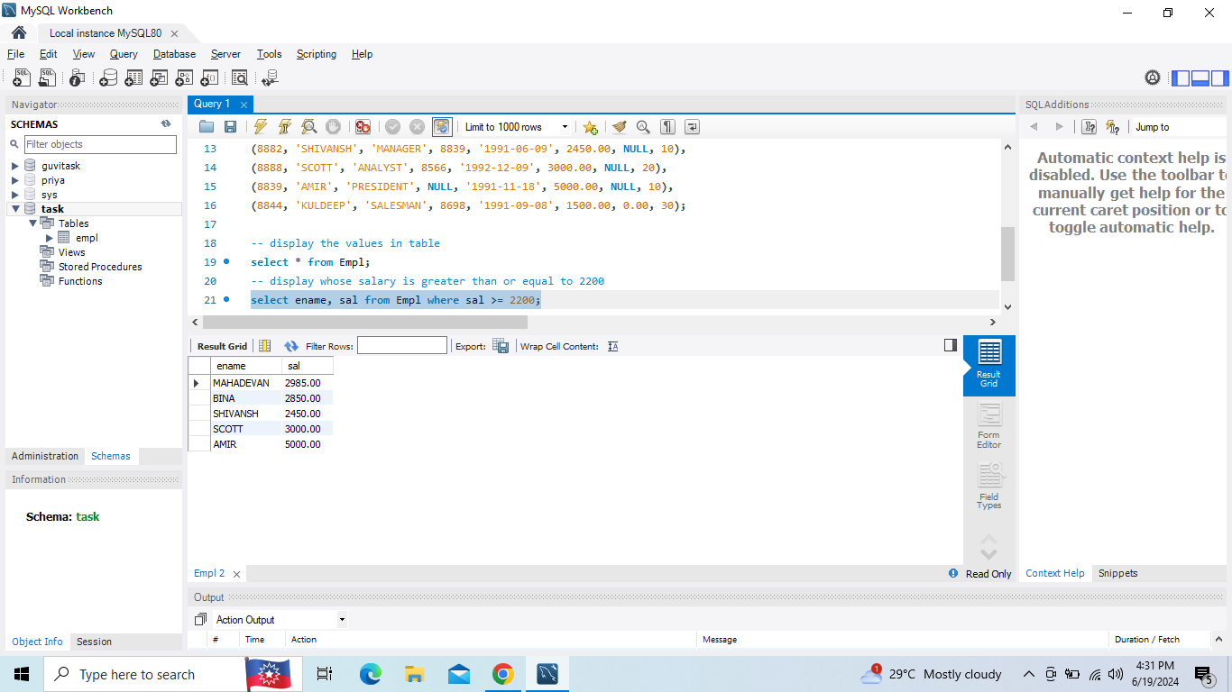

**1)B. Display who not getting commission**

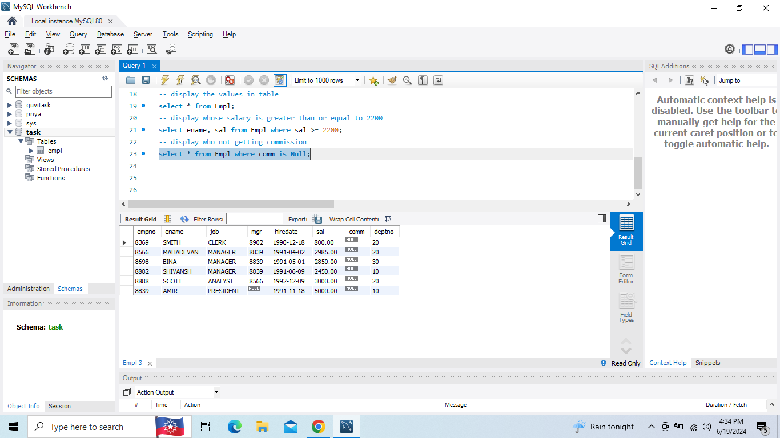

**1)C. Display who don’t have salary between 2500 to 4000**

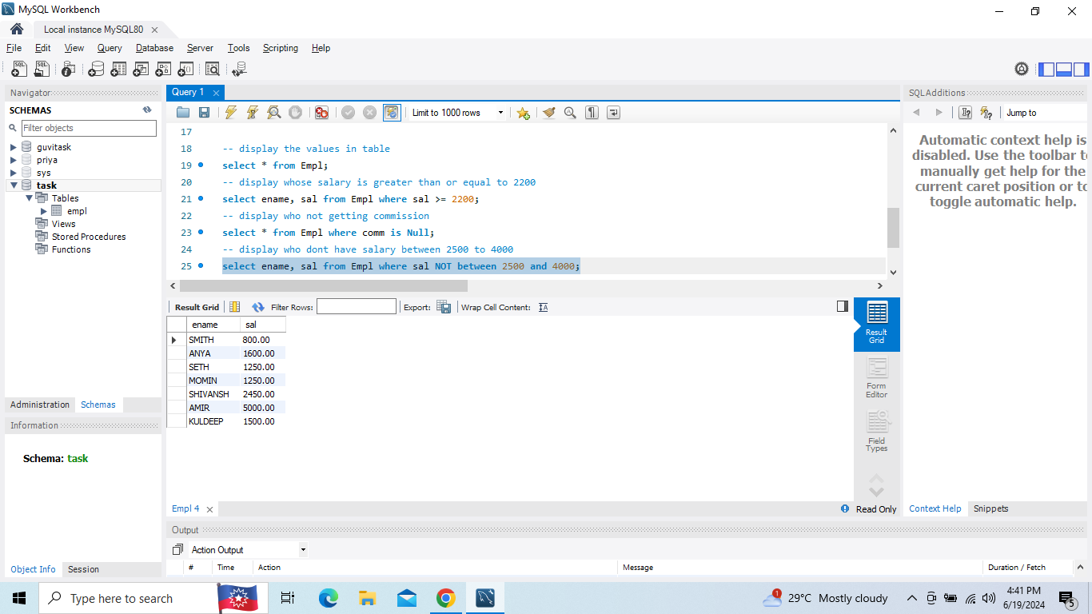

**1)D. Display who don’t have manager**

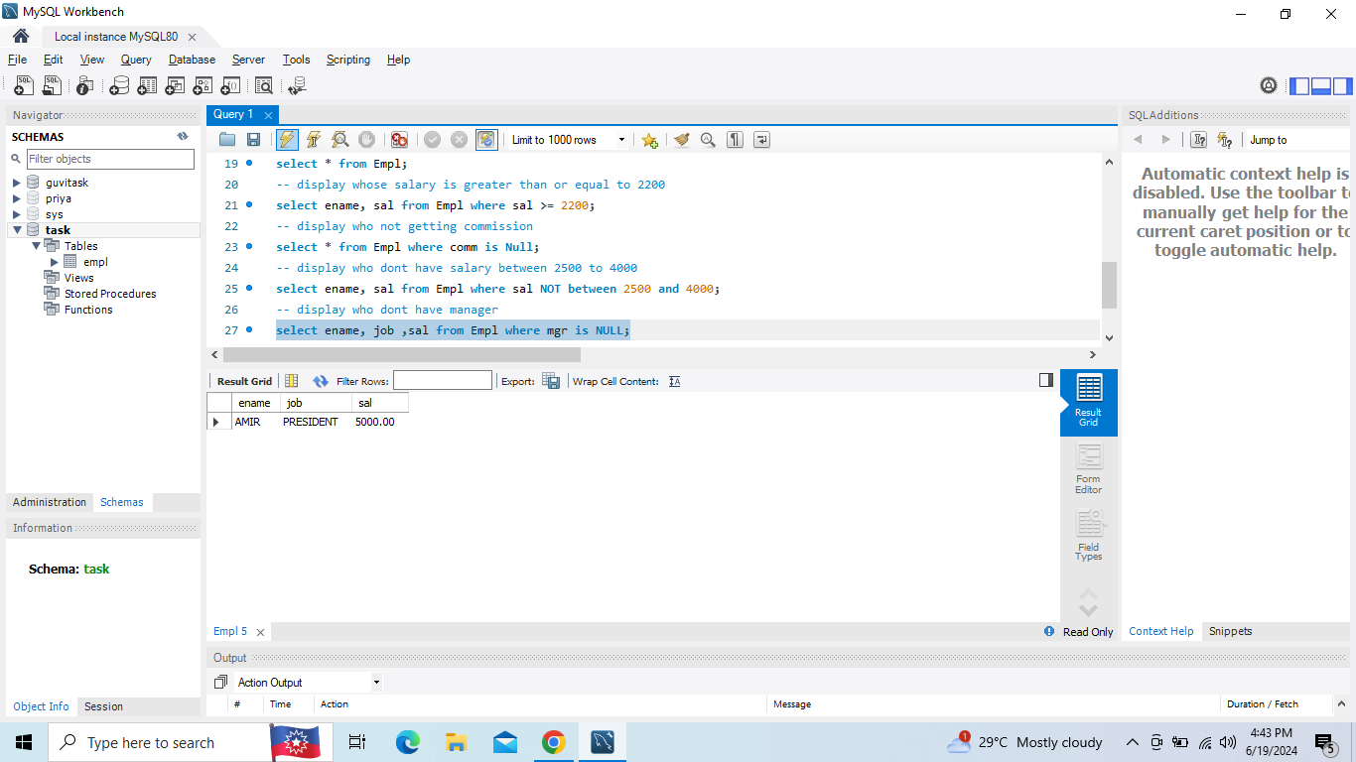

**1)E. Display whose name contains A as third letter**

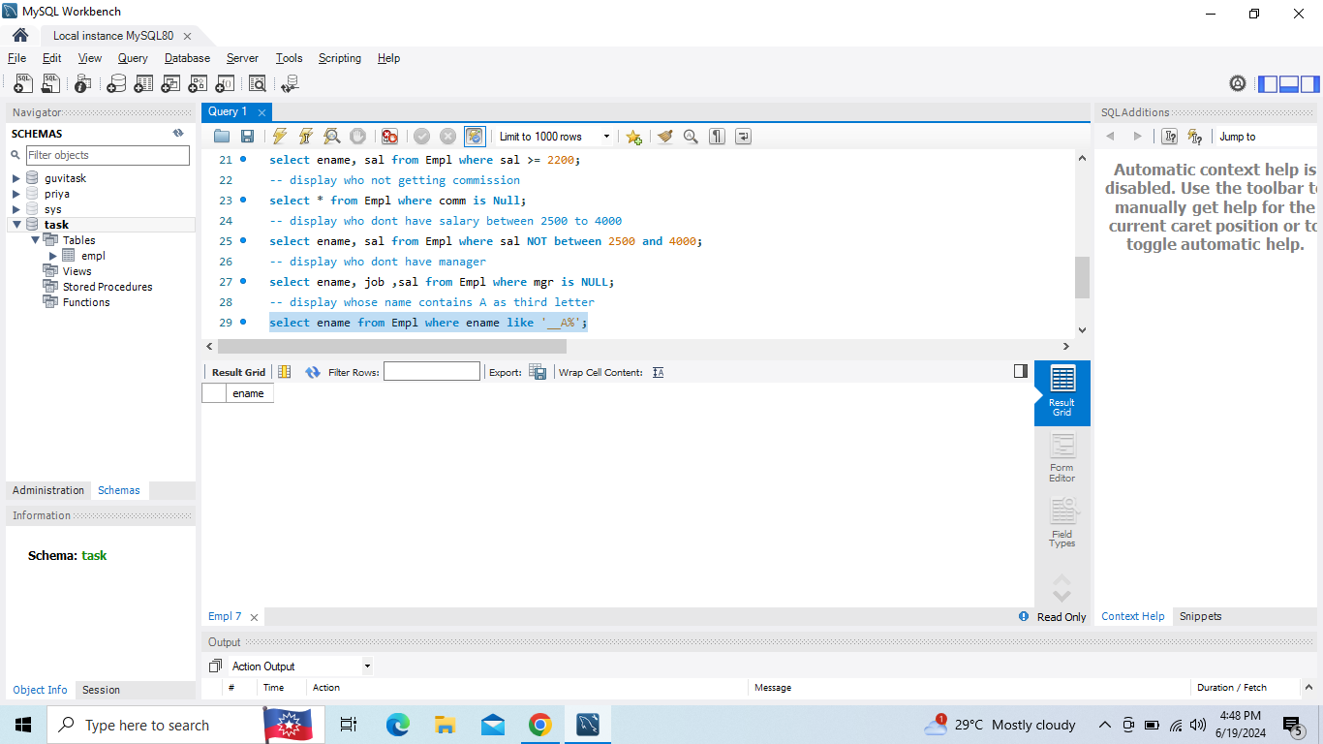

**1)F. Display whose name contain T as last letter**

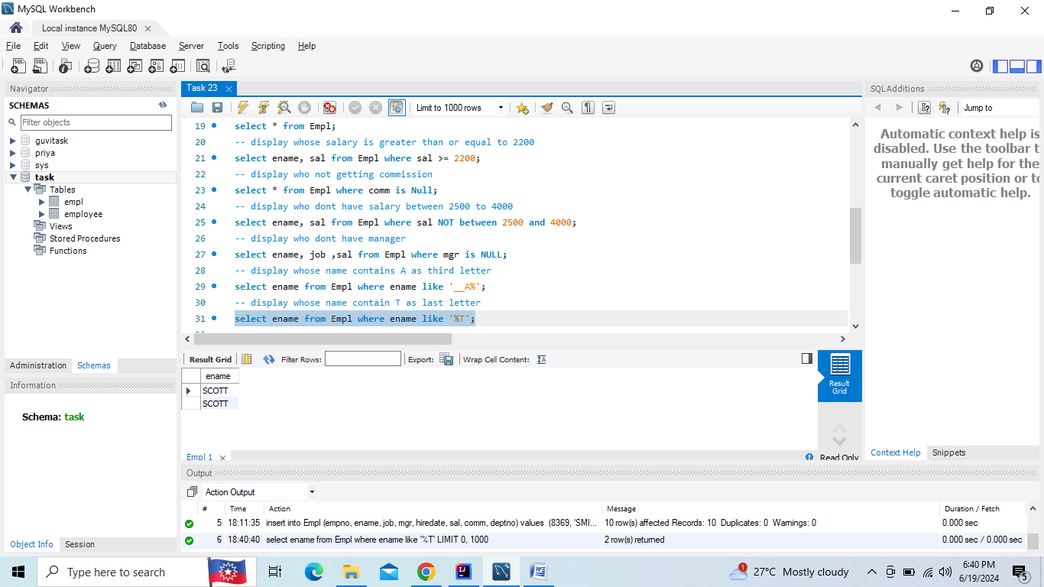

**2.Write a program for jdbc to connectivity and insert the below data**

